The Checkout Experience with
Gift Certificates/Gift Cards

This chapter describes the checkout experience for buyers who purchase gift certificates from our website and the checkout experience for recipients who redeem our gift certificates for online purchases made from our website. Buyers of gift certificates do not need PayPal accounts. Recipients of gift certificates must have PayPal accounts or sign up for PayPal accounts at the time of redemption.

The Checkout Experience When Purchasing Gift Certificates

NOTE: This topic describes the normal experience for buyers who purchase gift certificates from our website. Some buyers have different experiences, based on account balance, status, or settings.

Here are the steps a buyer takes when purchasing a gift certificate:
1) Buyer clicks our ‘’Buy Gift Certificate’’ button.
2) Buyer enters his details in the form fields as shown below.
Don’t forget to choose the amount you like for your gift certificate and write any message for the receipient.

Figure 1.1 Sample of ‘’ Send a Gift Certificate Page ‘’ :

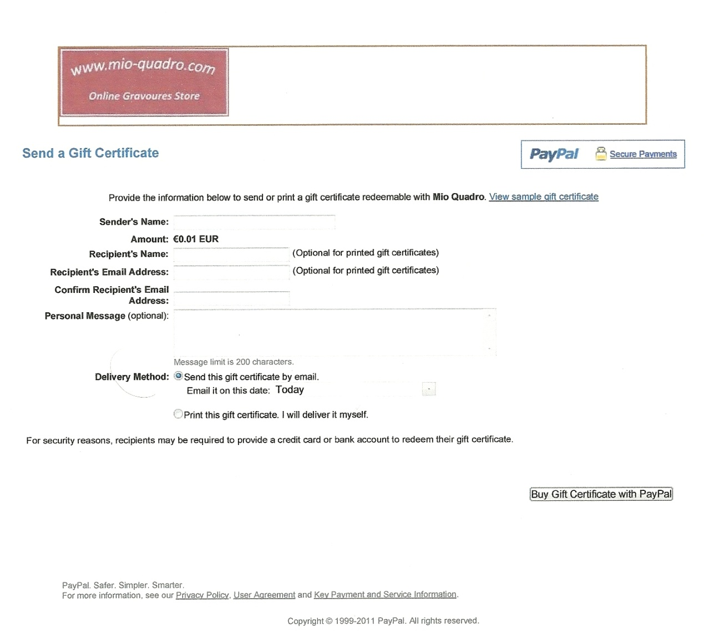

3) Buyer clicks the ‘’ Buy Gift Certificate with PayPal ‘’ button.
4) Buyer reviews the transaction details on the checkout page as in Figure 1.2 below.

Buyer either logs in to PayPal with his account credentials or (if buyer does not have a
PayPal account) clicks the ‘’ Click Here ’’ button and provides payment information such as billing address and credit card information.

Figure 1.2 Preview of transaction details :
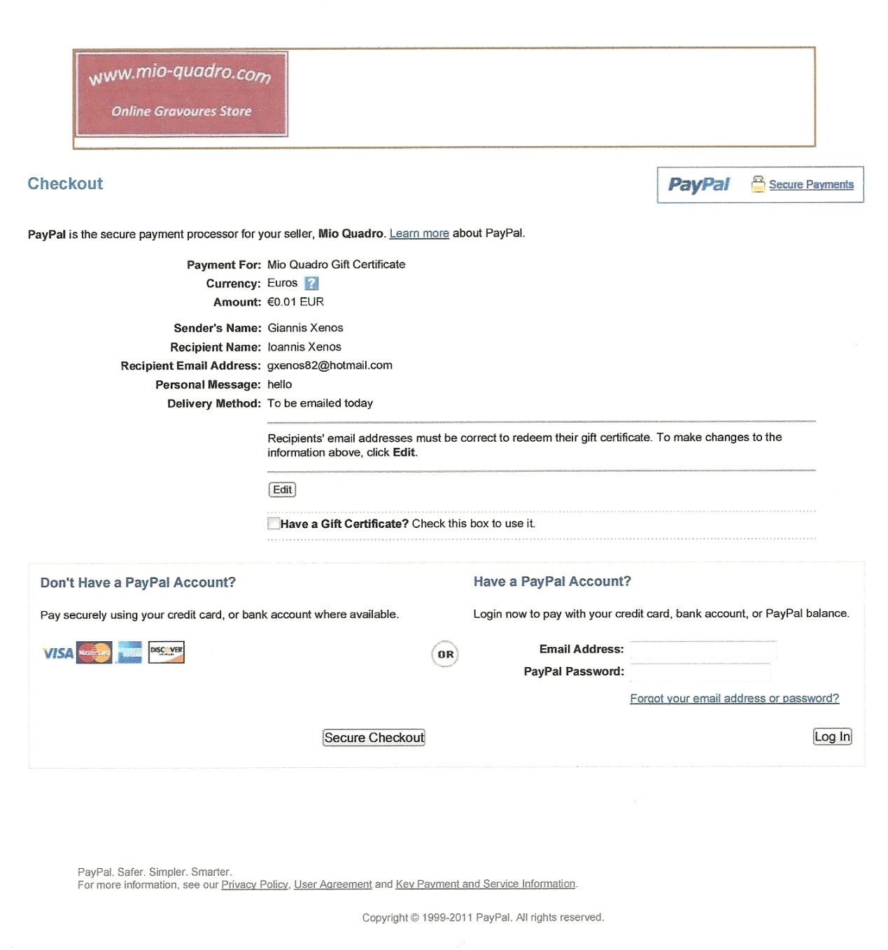

5) Buyer clicks Continue.
6) Buyer approves a funding source and clicks Pay to Submit his gift certificate purchase.
7) Buyer is directed to the You Made a Payment page.
8) Buyer has the option to purchase another gift certificate or click the Done button.

Recipient Email Terms

The buyers of gift certificates should not to include a recipient email address if they are not sure who they will give the gift certificate to, or if they plan to print and personally deliver it.
If a recipient’s email address is indicated on a printed gift certificate, it may be redeemed only by the owner of that email address. If a gift certificate is sent to the wrong email address or is lost, it can be canceled or refunded at no charge within 60 days of the purchase date.

The Checkout Experience When Redeeming Gift Certificates

When a gift certificate is delivered to the recipient, instructions are given on how to redeem the gift certificate. Recipients must have a PayPal account or sign up for one in order to redeem their gift certificates. This safeguard is intended to protect all parties involved.

Your gift certificate will look as follows :

Figure 1.3 Example of a PayPal Gift Certificate :

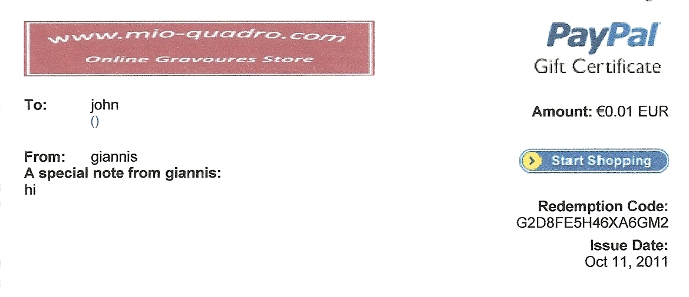

Accessing our Website to Redeem a Gift Certificate

Gift certificate recipients can access our website in several ways:

1) Clicking the ‘’ Start Shopping “ button in emailed gift certificates.
2) Manually typing our Shopping URL : www.mio-quadro.com into a web browser.

Gift Certificate Redemption Page Options

Recipients can redeem gift certificates in several ways:

1) Click a Buy Now button.
2) Click any type of checkout button we have customized in our website, including
shopping cart buttons.
3) Click a Purchase button or link in an email.

When recipients select an item to purchase using PayPal, they are taken to the PayPal
Checkout page.

How Gift Certificate Redemption Works

The following steps outline how recipients of gift certificates redeem them when they pay for purchases when they use their gift certificates as the primary funding source:

1) Recipient verifies the order details on the Review “ Your Order Summary “and choose either logs in to PayPal with his account credentials or (if buyer does not have a
PayPal account) clicks the Click Here button and provides payment information such as
billing address and credit card information.
2) Recipient selects a gift certificate by clicking the Select Code button or by entering a
redemption code in the field provided.
3) Recipient clicks Continue Checkout and the payment has been completed.
4) Then you transferred automatically in our website to fill in your billing and shipping details and finish your order.

Figure 1.4 Preview Page With Your Order Summary

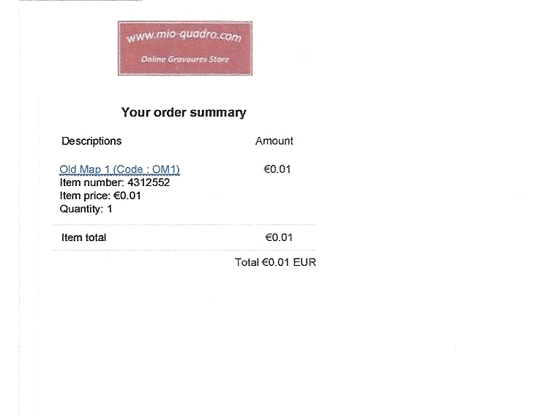

A ) If you have paypal account choose : ‘’ Have a Paypal account ’’

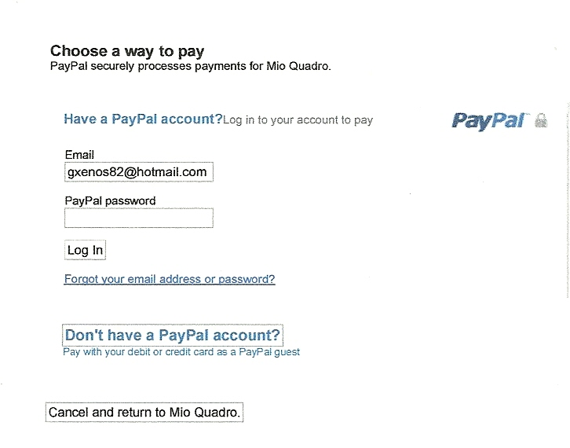

Log in to your Paypal account .

Then you will transferred in your Paypal account as follows :

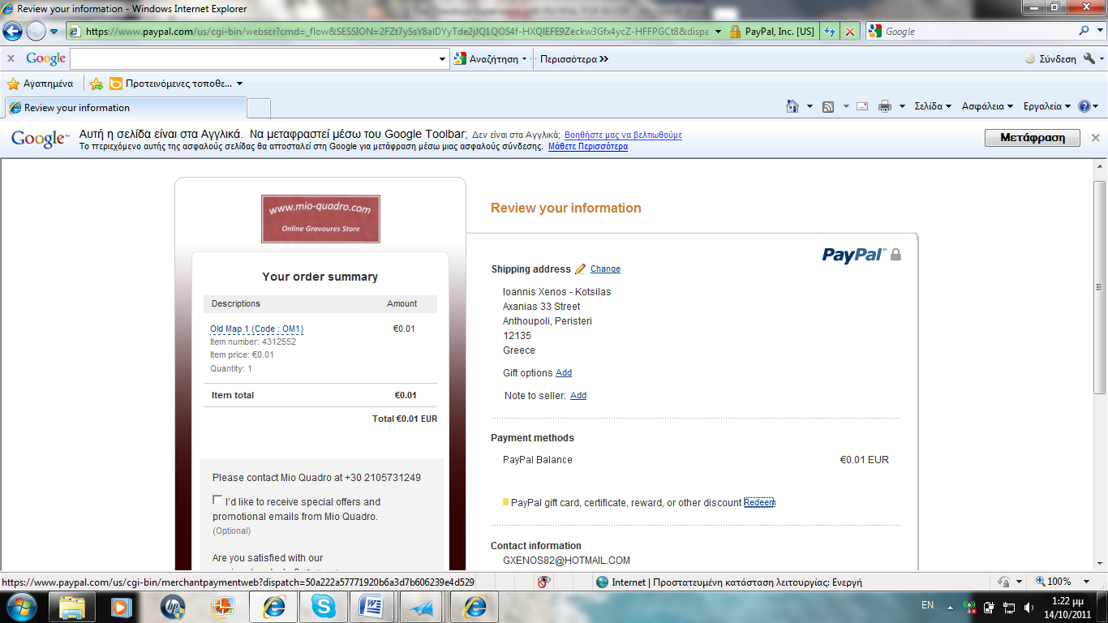

Here you can choose if you like to redeem your gift certificate by clicking the Redeem link, then you will see the following pop up window :

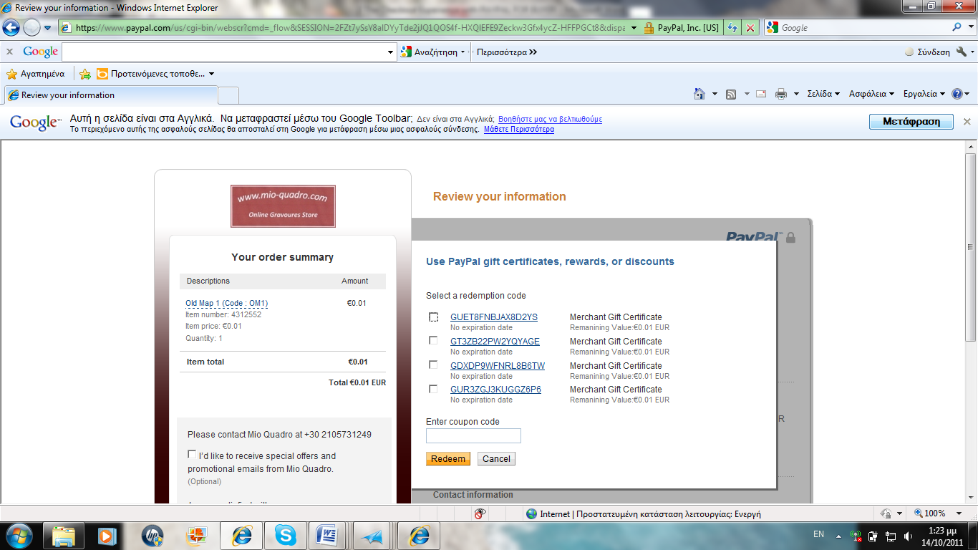

In this window you can put your gift certificate code or you can choose more certificate from your list. Then click Redeem button to continue .
In case that the amount of your purchase is bigger than the amount of the gift certificate you will be asked to pay the rest amount from your paypal balance or credit/debit card.

When you finish click Continue button , so as to finish the payment process.
Then you will be transferred in our website to fill in your billing and shipping details and finish your order.

b) If you don’t have Paypal account choose : “ Don’t have a Paypal account “

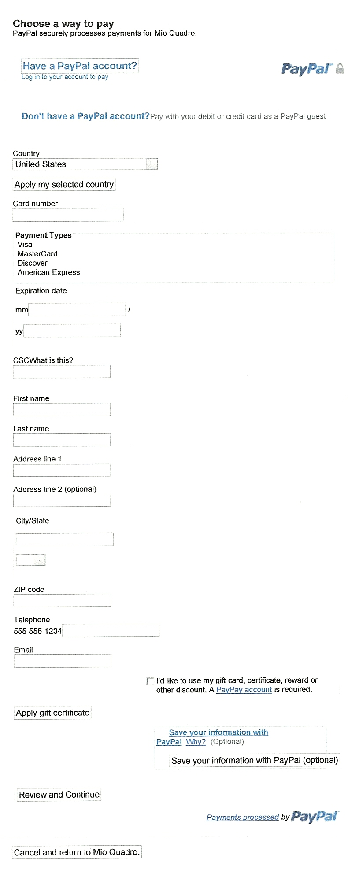

Fill in all the details you will be asked , so as to pay with your credit/debit card.

Then ckick the Continue button to finish the payment process.

Once you have completed your purchase, you will receive an email notification of the
payment.
Glossary

Buyer: Anyone who purchases a gift certificate from a merchant. The buyer may or may not provide a recipient email address. The buyer is not required to have a PayPal account in order to purchase a gift certificate.

Recipient: Anyone who receives a gift certificate from a buyer. An email is sent to the
recipient explaining how to accept and redeem the gift certificate.

Unilateral Gift Certificate Recipient: Gift certificate recipient who does not yet have a
PayPal account. Although this implies a new user, it can also represent situations where a gift certificate is sent to an email alias that has not been registered by an existing PayPal user.

Shopping URL: The web address on a merchant website where recipients go to redeem their gift certificates.

Cancel URL: The web address where buyers are taken when they click the Cancel button.

Return URL: The web address where buyers are taken after they complete a transaction
Successfully.

Redemption Code: A code of letters and numbers that uniquely identifies a gift certificate or other incentive.

Pending Balance: The collateral balance in a PayPal account, where gift certificate proceeds are held until the time of redemption.

