Print your coupon

Save 20,00 Euros
with each order
of 100,00 Euros

Valid till : 31/12/2018
( For online & Retail Shop ).

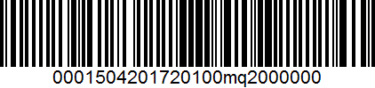

For shopping in retail shop print this coupon and view it in the employee to scan it.
For online shopping use the code : mq20 in the checkout process.
Not Valid for sales period and for products in offer. One coupon per order.

